Lab 4: Spatial Analysis

Geoprocessing, density, and charts

Geospatial Operations Support Team

(GOST)

Katie McWilliams

Benjamin Stewart

GOST@worldbank.org

**LAB FOUR: Spatial Analysis**

*In this exercise, we will determine which types of land cover are most susceptible to fire in Ethiopia. We will use various geoprocessing tools to calculate the density of fire events (the number of fire events occurring per square kilometer). The final deliverable will be a map comparing land cover type to fire events that have occurred in Ethiopia, as well as a pie chart that shows the density of fire events for each land cover type.*

EXERCISE OBJECTIVES

1. Become familiar with geoprocessing techniques and tools
2. Calculate density values
3. Create a chart

**PART 1: Adding data, symbolizing land cover information**

1. Open a new, blank document in ArcMap.
2. Navigate to the desktop GIS Training folder, open it, and add the three shapefiles that are in the Lab 4 data folder: **Fires, Vegetation, and Countries.**

*The Fire layer is a product of the Fire Information for Resource Management Systems (FIRMS), and is based upon work of NASA, University of Maryland, FAO, and Conservation International. The file shows the location of all fire/hotspot detections within a 7 day period (in this case, March 15th- March 22nd 2011). The metadata and link for downloading is at:*

<http://earthdata.nasa.gov/data/near-real-time-data/data/firms/active-fire-data#tab-content-1>

1. Turn off the **Fire** and **Countries** layers and observe the **Vegetation** layer by itself. Note that, when symbolized in one color, it is impossible to determine which polygons represent which vegetation types. (Look in the attribute table under the field ‘VegType’ to see which types of land cover are represented on the map).
2. Right-click on the **Vegetation** layer, go to Layer Properties > Symbology. Use the Unique Values technique (under the Categories option) to map the data from the ‘VegType’ field. Make sure to click ‘Add All Values’ and choose an appropriate color ramp. The color distinctions will make the map easier to work with. Once you are finished, turn the **Fire** and **Countries** layers back on.
3. If it isn’t there already, drag the **Countries** layer so that it is in between the **Fire** and **Vegetation** layers. Click on the colored box below the layer name to open the symbol selector, and change the fill to ‘No Color.’ Then make the outline width black and thicker (around 1pt). Click OK. Now you can easily see all three layers.

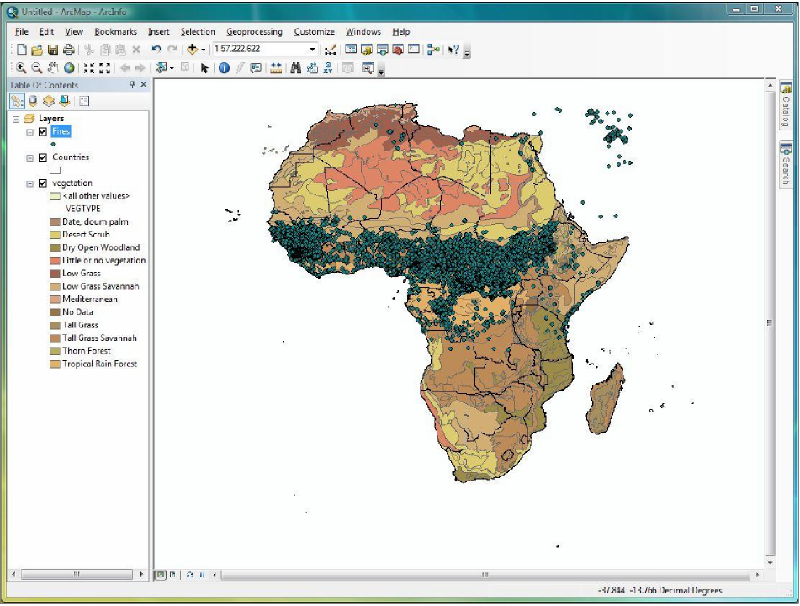

**PART 2: Selecting by Attributes and Location; Creating new layers from selected features**

*In this exercise, we will be focusing on the country of Ethiopia. It is necessary to narrow down our Country, Fire, and Vegetation data sets accordingly. We will use two different methods: selecting by attributes and selecting by location.*

1. First, we are going to sub-select Ethiopia from the **Countries** layer. Open the **Countries** attribute table.
2. 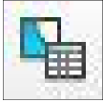On the main toolbar, click on the third button from the top left, the ‘Select by Attributes’ button. This will open the Standard Query Language (SQL) wizard. (Another way to access the select by attributes wizard is to click the top left button in the attribute table, called ‘Table Options’ and then choose Select by Attributes.)

*Selecting by attributes allows you to build a statement, or query, that tells ArcGIS which features to select. Since we are looking to select one particular country, we are going to build an expression to reflect that.*

1. Note that the top box contains a list of all of the fields in the attribute table. Scroll through the list and double click on the ‘Name_English’ field. The field should appear in the dialogue box at the bottom of the screen.

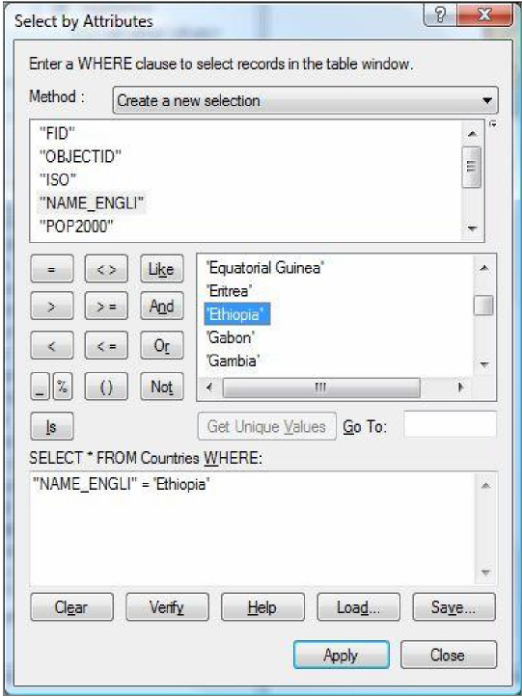

1. We want the name of the country selected to be Ethiopia, so click on the equals ‘=’ button, then click on the ‘Get Unique Values’ button. All the different country names that are held within the ‘Name_English’ field should appear in the center box.
2. Scroll through the list and double click on Ethiopia. Now, the expression you’ve build should read “Name_English” = ‘Ethiopia.’ Click ‘Apply’ and then ‘Close.’
3. Ethiopia should now be highlighted in the main attribute table, and on the map.

*Note: Select by Attributes is most useful when selecting multiple features, such as all countries whose populations are between five and ten million.*

1. With Ethiopia still selected, close out of the attribute table. Right-click on **Countries** and scroll down to ‘Selection’ and then over to ‘Create Layer from Selected Features.’

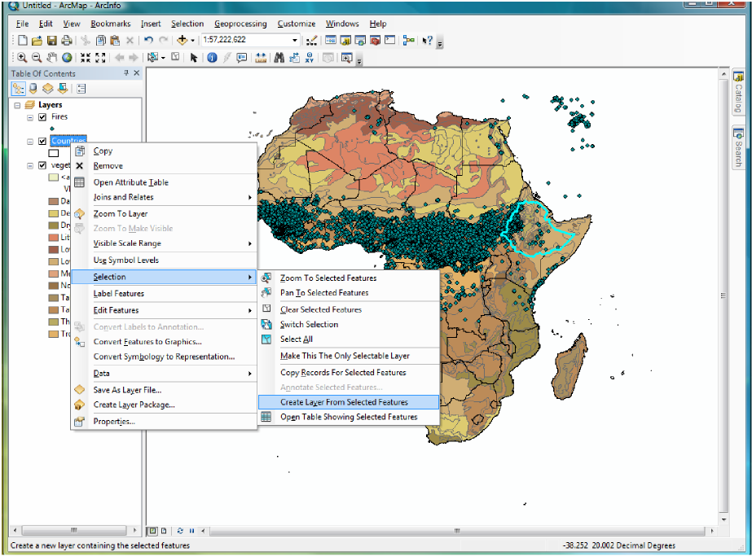

1. A new layer should appear at the top of the Table of Contents, called **Countries Selection**. Click twice slowly (don’t double click, that will open the layer properties) until the name becomes highlighted, and change it to **Ethiopia**.

*Note: Creating a layer from selected features only transfers the data from your selection, it does NOT save it. This layer exists only cosmetically within the context of your map- if you look in your Lab 4 folder, nothing has been saved. You do not have to do this now, but if you wish to create a whole new shapefile, you must right click on the* ***Ethiopia*** *layer, and go to Data > Export Data. This will bring up a dialogue box in which you can save you sub-selected information as a .shp file, making it permanent.*

1. Now that we have our Ethiopia layer, we no longer need the **Countries** layer. Right click on **Countries** and select ‘Remove.’

*We are only interested in fires that have occurred in Ethiopia, so now we are going to narrow down our* ***Fire*** *data. Selecting by attributes is not appropriate in this situation because there are no fields in the* ***Fire*** *attribute table upon which to base the selection- meaning there is nothing that references the country in which each fire is occurring. Therefore, to complete this task we must use a different process: Select by Location.*

1. In the top menu bar, choose Selection > Select by Location.

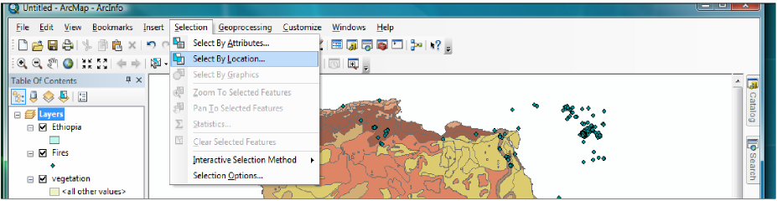

*Select by Location is very similar to Select by Attributes- we must build an expression that tells ArcGIS which features to select (except this time, we are going to select features based upon their location, not their name or any other attribute).*

1. In the top expression box, make sure that it reads ‘select features from’ (the default). See the image on the next page for reference.
2. Since we want to narrow down the **Fire** layer, check the box next to **Fire** in the target layer box.
3. Select **Ethiopia** as the source layer.
4. We want to select only those fires that have occurred within the boundary of the Ethiopia layer, so in the third expression box, select the option that reads ‘are within the source layer feature’ from the drop-down menu.

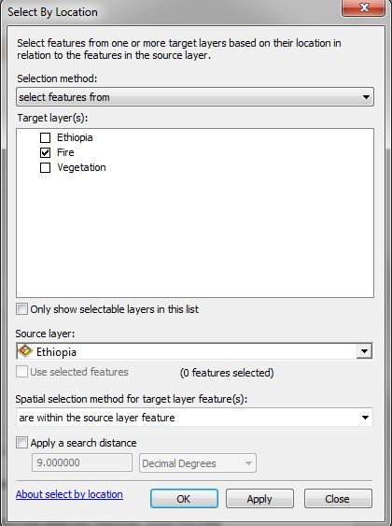

1. Click OK to run the tool. The fires within Ethiopia should be selected.
2. Right-click on the **Fire layer** and create a new layer from the selected features. Once the **Fire Selection** layer appears, you can remove the original **Fire** layer from the map.
3. Since we will be using the **Fire Selection** layer as the basis for the analysis later, it is best to export this data into its own file and save it.
4. Right-click on **Fire Selection** and go to data > export data. In the dialogue box, leave the default settings as they are. In the bottom output menu, click on the folder button to navigate to your Lab 4 Data folder. Name the new layer **Fire_Events**, and change the ‘Save as type’ to shapefile.
5. Click save, then OK.
6. When the file has been saved, click ‘yes’ to add the new layer to the map. You can now remove the **Fire Selection** layer from the display.
7. At this point, it is best to save your map. Go to File > Save As, and save your map as Map1.mxd in the Lab 4 folder.

*We have narrowed down the Fires and Country data down to our area of interest- Ethiopia. The next step is to limit the Vegetation data to this same area. Doing so is a more complex process, though- unlike the other two layers, we cannot simply select by attributes or location. Nothing in the vegetation attribute table references countries, so we cannot use this function. And selecting by location will not work because the various land cover polygons within the Vegetation layer extend beyond the border of Ethiopia. We cannot select just those polygons that occur within, intersect, are contained by, touch the boundary of, etc., Ethiopia because the result will either select more data than necessary, or will not select enough.*

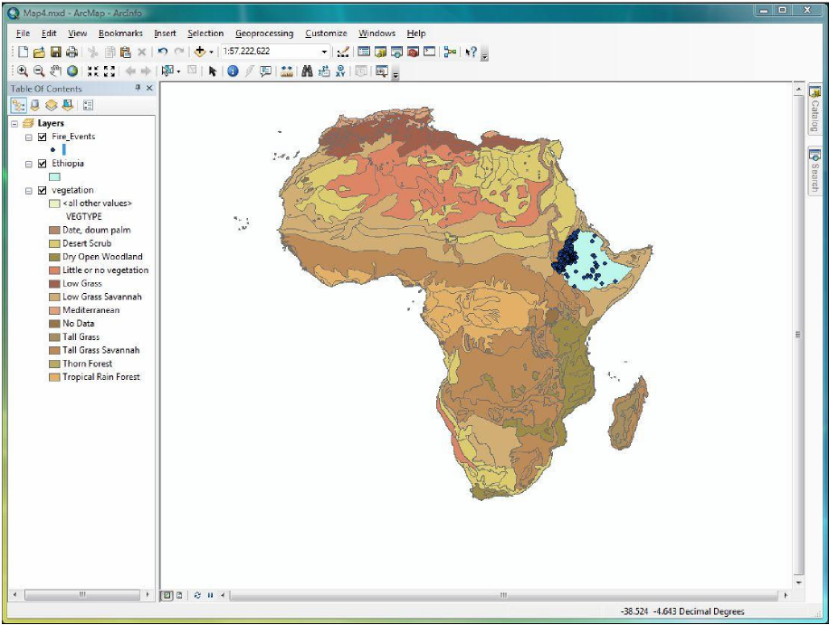

*What we need is to essentially create a cut-out of the vegetation layer, using the Ethiopia country layer as the boundary.*

**PART 3: Introduction to ArcToolbox and basic Geoprocessing tools**

*In this part of the exercise, we will be working with ArcToolbox and some of the most common geoprocessing functions. ArcGIS offers hundreds of tools for the analysis of both raster and vector layers- tools for projecting layers, joining datasets, converting rasters to shapefiles, calculating statistics, etc. For the purposes of this lab we will work with some of the most common geoprocessing tools.*

1. In the top toolbar, click Geoprocessing and look at the tools listed:

***Buffer:*** *This tool allows you to select a zone of interest within a specified distance from a feature on your map. You can use any type of vector as an input- points, lines, or polygons. For instance, you can use the Buffer tool to highlight the area that is within five kilometers of a city, or the area within one kilometer of a river. This tool creates a new output file that demarcates the boundaries of the buffered area.*

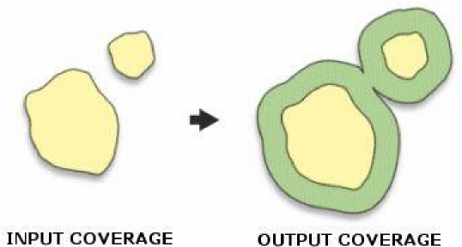

***Clip:*** *The clip tool allows you to extract a portion of one layer by using the boundary of another feature. The input layer (the layer to be clipped) can be any type of geometry- point, line, or polygon. The feature used to clip, however, must be a polygon. A new layer will be created that has the attributes of the input layer but the boundary of the clipping layer.*

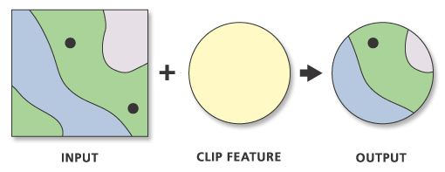

***Intersect:*** *The intersect tool will select (and create a new layer from) only those areas that intersect between multiple input layers.*

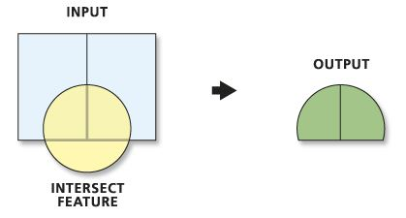

***Union:*** *The union tool can only be used when working with polygon files- points and lines are not allowed. Running this tool on two or more polygons will create one output layer that contains the information from all the input files.*

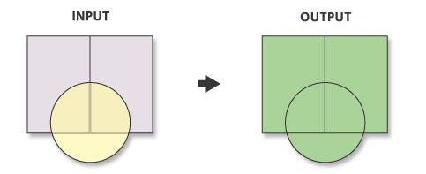

***Merge:*** *A merge will combine the input features from multiple input sources into one new file. The input sources must be the same, but they can be point, line, or polygon. They can also overlap- Arc will automatically recognize and march the data.*

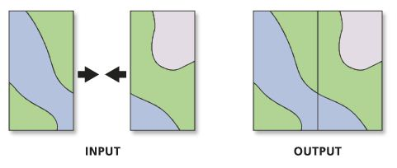

***Dissolve:*** *Combines features in one layer based upon a single specified attribute field. In other worse, it simplifies complex files. The output file will contain one attribute field that holds only the information from the field upon which the dissolve was based.*

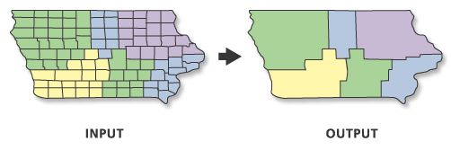

1. Since our goal is to use the boundary of **Ethiopia** layer to essentially cut out a portion of the **Vegetation** layer, the most appropriate tool to use is the Clip. Under the Geoprocessing drop-down menu, select the Clip tool.

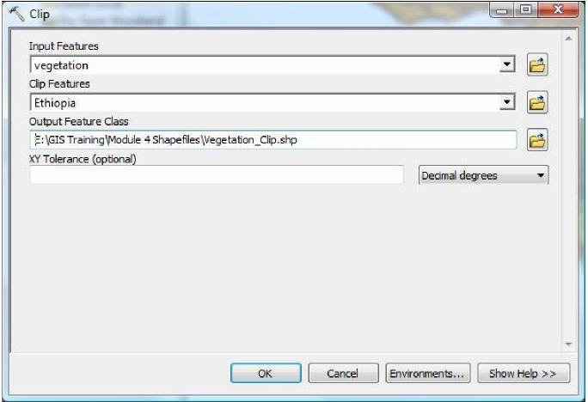

1. In the Input Feature drop-down box, select the layer that you would like to be clipped. In this case, it is the **Vegetation** layer.
2. In the Clip Features box, select the layer that you would like to use as the boundary- the **Ethiopia** country layer.
3. The Output Feature Class box specifies where you would like to save the new file. Unlike creating a layer from selected features, using a geoprocessing tool will automatically create a new shapefile.
4. Click the folder next to the output box, and make sure that the path leads to the Lab 4 data folder, and change the name to **Vegetation_Clip**. Click OK to run the tool.
5. When the clip is finished, turn off the original **Vegetation** layer, as well as the **Ethiopia** country layer. Right click on the new **Vegetation_Clip** layer and select ‘Zoom to Layer’ to center it on the screen. Your result should look something like this:

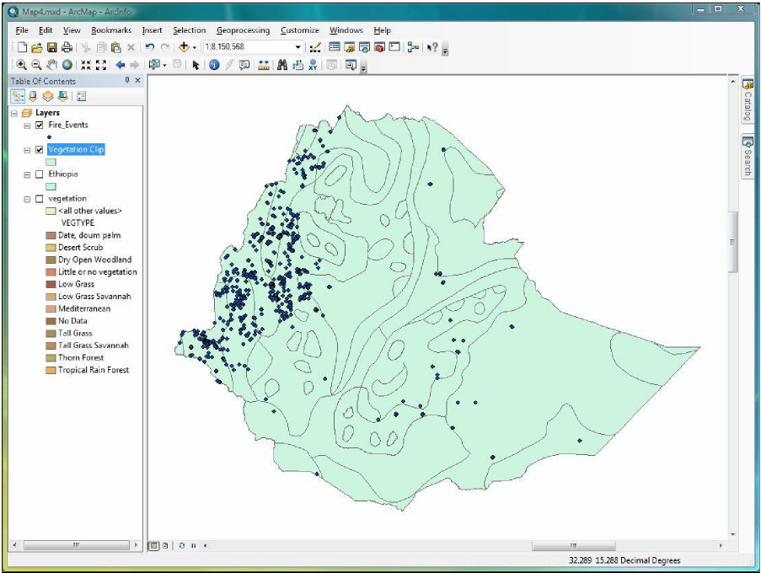

1. Now, remove the original **Vegetation** and **Ethiopia** layers, since they are unnecessary.

*We now have a map that shows the different land cover vegetation types within the country of Ethiopia, as well as the location of recent fire events.*

**PART 4: Dissolving, Batch Projecting, Calculating Area**

*In this part of the exercise, we are going to calculate the area (in square kilometers) of the various land cover types within Ethiopia. Doing so will be useful later when we try to determine the density of fire events in each land cover type. Calculating area involves 1) projecting all of the data into an appropriate coordinate system; 2) combining the same land cover types into one attribute; and 3) working with the attribute table to create a new field and calculate the geometry of the polygons.*

1. The first step in calculating the area is to make sure the layer has the correct coordinate system. Open the **Vegetation_Clip** layer properties, and click on the ‘Source’ tab.
2. In the data source box, notice that the Geographic Coordinate System has been defined as WGS_84. However, a geographic coordinate system only allows us to calculate area in Decimal degrees- not in miles, kilometers, or any other measurement system. To calculate area in units we are familiar with, the layer must have a Projected Coordinate System.

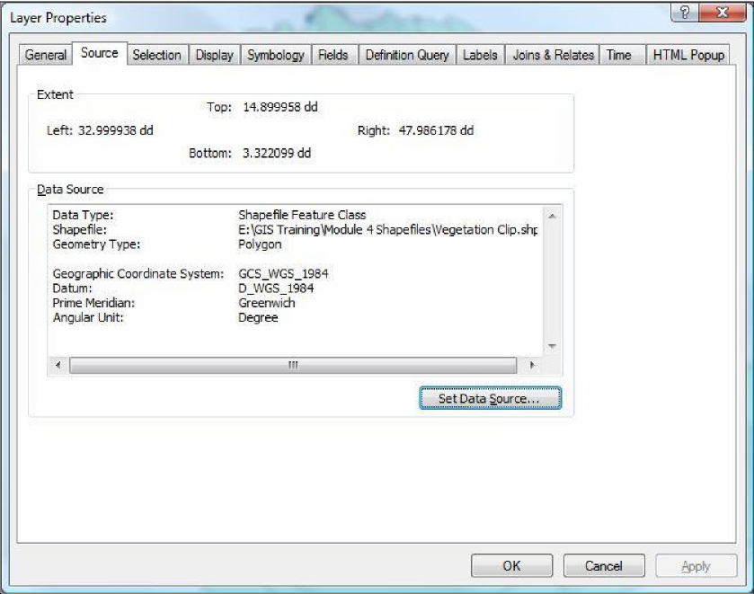

*Before we project the* ***Vegetation_Clip*** *layer, remember that doing so will change its spatial reference. Since we are working with two layers that are currently aligned, it would be unwise to project one layer without projecting the other.*

1. Open the layer properties for **Fire Events** and check its coordinate system. No projected system has been defined here either, so it will be easy to project both files at once.
2. 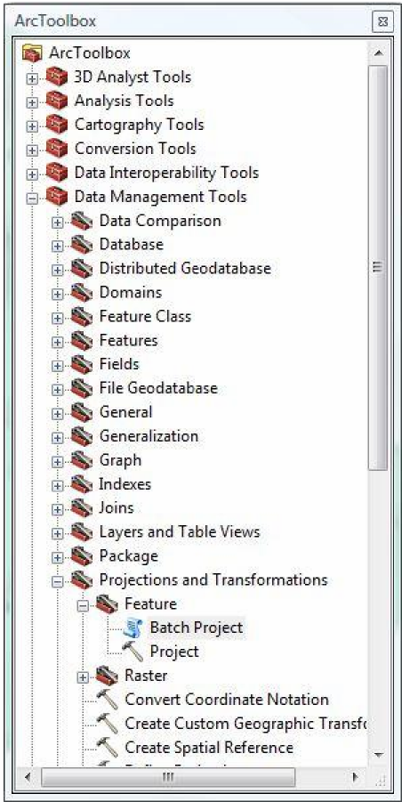Go to the main toolbar and click on Geoprocessing > ArcToolbox to open it. Double click ‘Data Management Tools,’ then ‘Projections and Transformations.’ We are working with features, not rasters, so click on ‘Features.’ (Features refer to vector data.)

*If we were simply looking to project one layer, we would use the ‘Project’ tool. But as we are projecting two layers, it is easier to use the ‘Batch Project’ tool so we can save time.*

1. Double click on the ‘Batch Project’ tool to open it.
2. Click on the folder to the right of the ‘Input Features’ box. Arc should automatically connect to the Lab 4 Data folder- if not, use the drop-down menu to navigate to it. All of the shapefiles you have created should appear, but we only need two: **Fire_Events** and **Vegetation_Clip**. Hold the control key and click on each one, then click OK.
3. Click the folder next to the Output Workspace box. Select the folder you would like to save the new files to- in this case, the Lab 4 Data folder is best (note: you might have to click on the ‘Up One Folder’ arrow next to the drop-down menu in order to select the folder for Lab 4). Once it is selected, click ‘Add.’
4. Click the button next to the Output Coordinate System box. This is where we are going to choose which Projected Coordinate System to use.
5. When the Spatial Reference Properties screen appears, expand the Projected Coordinate Systems folder, then Continental, then Africa. Since we are dealing with a fairly small area (i.e. a single country) it is best to use a coordinate system specific to Africa. A system designed at a worldwide scale would not be as accurate.

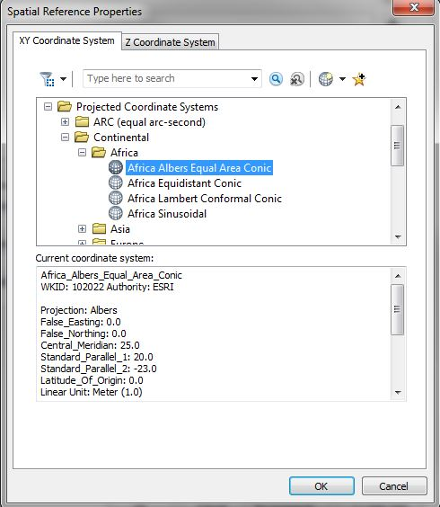

1. Since our ultimate goal is to measure area, one good option is the Africa Albers Equal Area projection. Choose this from the list, then click OK.
2. Now that we have selected which layers are to be projected, the folder in which to save the new files, and chosen a coordinate system, click OK to run the Batch Project tool.
3. 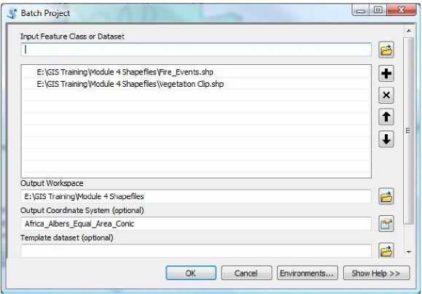After it is finished, the new layers will not automatically appear on the map. Click on the ‘Add Data’ button and look in your Lab 4 data folder- you should see two new files: Fire_Events_1 and Vegetation_Clip_1. (Arc will never overwrite old files, so it added a ‘1’ to the end of each shapefile name to distinguish between the old unprojected files and the new outputs.)
4. Add the two new files to your map, then remove the two old files.
5. While the new output may look the same, check the source layer properties for each other new files. Notice how the Albers Equal Area projection is now listed in the source data.

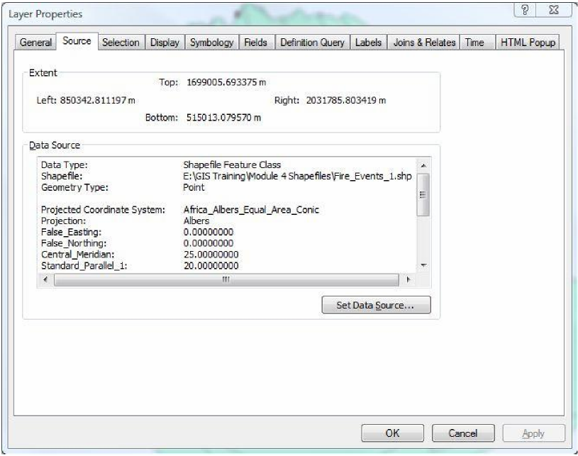

1. While our layers have now been projected, we are still not quite ready to calculate the area of the land cover types. Open the attribute table of the **Vegetation_Clip_1** layer and look at the VEGTYPE field. Notice how the same vegetation types (Low Grass Savannah, Tall Grass Savannah, Thorn Forest, Tall Grass) appear in multiple rows.

*In order to calculate the area of each land cover type, we must first combine all the same types into one record. Otherwise, Arc will calculate the area of each individual feature/polygon in the table. To ensure our calculation results in one total area for each vegetation type, we must use another geoprocessing tool: Dissolve.*

1. Go to the geoprocessing menu and select Dissolve.
2. We are working with the **Vegetation_Clip_1** layer, so select this as the input feature.
3. Click on the folder to the right of the output feature class menu to navigate to your Lab 4 Data folder. Save the new file with the name **Vegetation_Dissolve**.
4. Under ‘Dissolve Fields,’ notice that all of the fields that appear within the **Vegetation_Clip_1** layer have appeared. Since we are trying to combine the same land cover types into one row, select ‘VegType’ as the dissolve field. Click OK to run the dissolve.
5. The resulting shapefile will look the same as the old file- the differences will be entirely within the attribute table. The new file should automatically appear on the display. Open the attribute table of both files to compare. The original file has multiple rows for the same vegetation type (below, left). Notice how in the new table there is only one row for each different land cover type (below, right).

*One other thing to note: when dissolving files, you lose every field in the original attribute table except the field by which you are dissolving. Be careful when running this tool and make sure that you do not need any of the other attribute data, as it will be lost.*

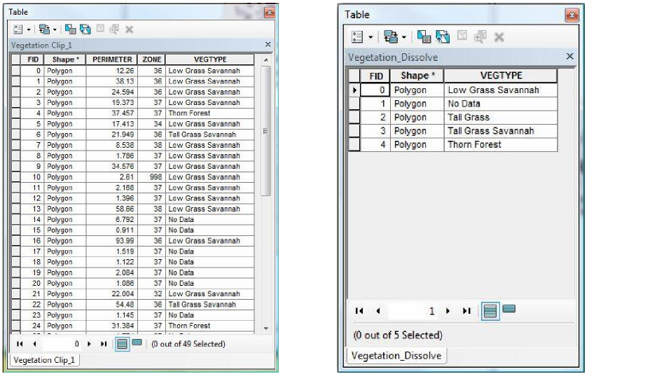

1. Since the dissolve has been successful, you can remove the **Vegetation_Clip_1** layer from the map.

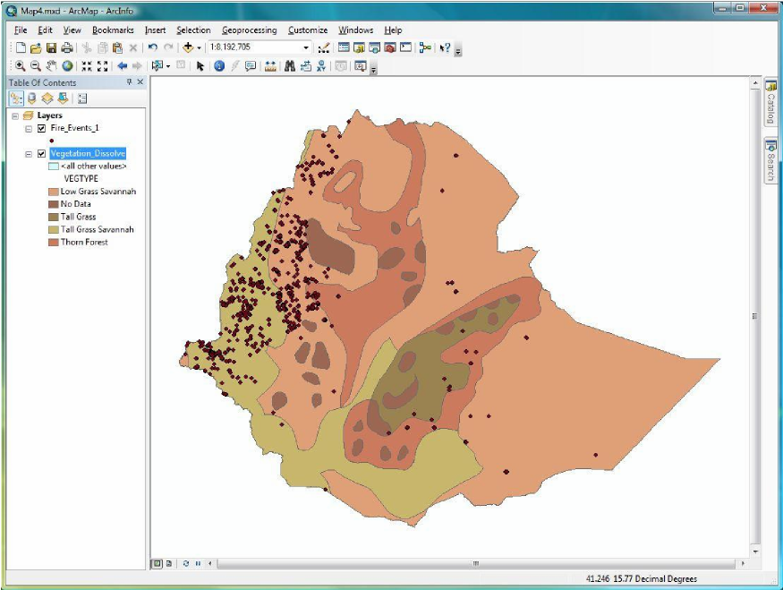

1. To create a more meaningful representation of the new **Vegetation_Dissolve** layer, right click on the layer name, go to Layer Properties > Symbology and symbolize the layer based upon the VEGTYPE field.
2. Select a color ramp you feel is appropriate, and click OK.
3. Go to File > Save to save your work.

**PART 5: Calculating Area, Adding New Fields within the Attribute Table**

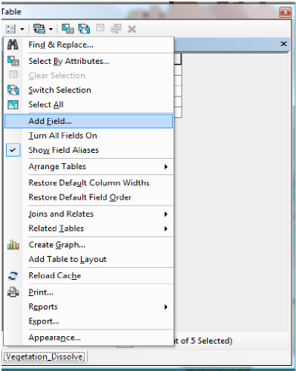*Now that the* ***Vegetation_Dissolve*** *layer is projected and has a workable attribute table, we can calculate the area of land that falls within each land cover type. To do so, we will create a new field within the attribute table and use the ‘Calculate Geometry’ tool.*

1. Open the attribute table of the **Vegetation_Dissolve** layer. Click on the top left button to open the Options menu, and scroll down the ‘Add Field.’
2. In the dialogue box, type ‘Area’ as the name of the new field.
3. Change the Type of field to ‘Float.’ (A float number is one that is more precise than a short or long integer- this type of field allows for decimal points. Since we are calculating area, Float is a better option than an integer field).
4. Click OK. The new field should appear at the far right of the attribute table.
5. To determine the area, right click on the heading of the ‘Area’ field and scroll down to ‘Calculate Geometry.’ Click ‘Yes’ if you see a warning message about performing a calculation outside of an edit session.

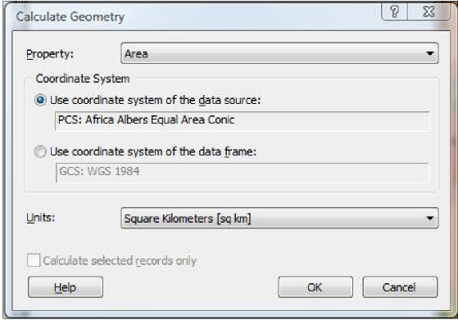

1. In the Calculate Geometry dialogue box, click on the Property drop-down menu to note the other calculations you can do. Make sure that ‘Area’ remains selected.
2. Leave the coordinate system as is (the Albers Equal Area should be the default).
3. Change the units to square kilometers, then click OK.
4. The area in square kilometers of each of the land cover types present in Ethiopia should appear in your Area field.
5. Close out of the attribute table and save your map.

**PART 6: Spatial Joins, Creating a Count Field**

*To calculate the density of fire events, we need two pieces of information: the area of each land cover type and the number of fire events that occur within each type. Now that we have determined the area, the next step is to work with the* ***Fire Events*** *layer to develop a count of events.*

*In order to determine the count of fire events, we need to spatially join the attribute data of the* ***Vegetation*** *layer to the* ***Fire Events*** *layer. You can think of this as laying the fire data on top of the vegetation data, and having Arc automatically count the number of fires that fall within each feature in the attribute table (i.e. each different land cover type).*

1. The Spatial Join is a tool found within ArcToolbox- open the box, then click on Analysis Tools > Overlay > Spatial Join. (See image on the next page for reference).
2. The Target Features layer is the destination layer- i.e., the layer where you would like all of the attribute data to end up. In this case, we want the Fire attribute data to be placed on the Vegetation layer- so Vegetation is our Target Feature.
3. In Join Features, select the layer whose attributes are being joined with the Target Feature- the Fire Events layer.
4. Use the folder button next to the Output Feature Class box to navigate to your Lab 4 Data folder. Name the new layer **Fire Count**.
5. Under Join Operation, leave the default setting of Join One to One. This is appropriate because we are matching each unique fire event with the single land cover type in which it occurred.
6. Click OK.

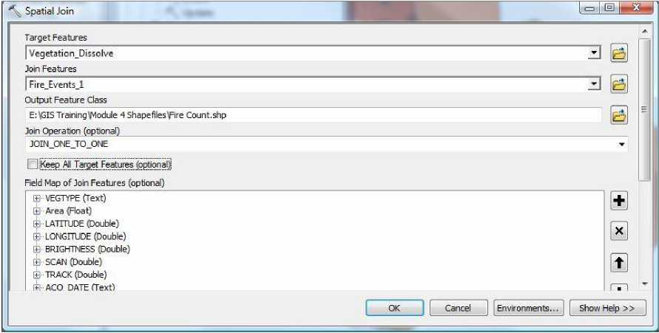

1. After the join is finished processing, it will add the new layer to the map. Open the **Fire Count** attribute table and notice the new Join_Count field. This field shows the number of fire events that fall within each of the Vegetation types.

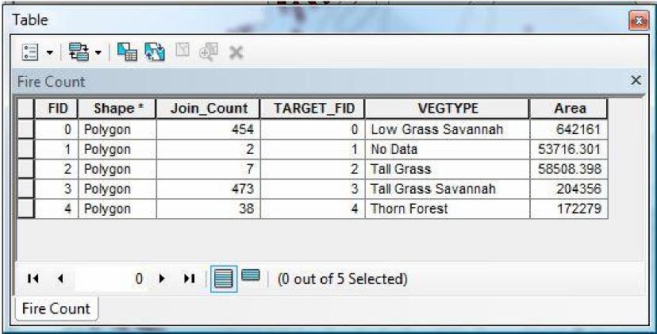

1. The final step is to use the Join_Count and Area fields (since we joined the fire layer to the vegetation layer, our area calculations are in the same attribute table) to calculate the density of fire events.

*Note: Since all of our needed information is now in the* ***Fire Count*** *Attribute table, you may remove the* ***Vegetation_Dissolve*** *layer from the display if you wish. If you do so, symbolize the* ***Fire Count*** *data by Vegetation type (go to the* ***Fire Count*** *layer’s properties > symbology). Otherwise, drag the* ***Vegetation_Dissolve*** *layer above the* ***Fire Count*** *layer in the table of contents so you can see the symbolized vegetation layers.*

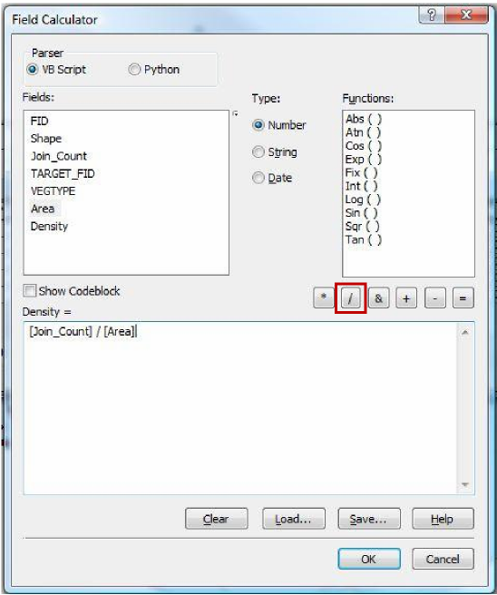

1. Using the same process as before, create a new field in the attribute table and name it Density (make sure to select ‘Float’ as the type of field).
2. Right-click on the density field and scroll down to ‘Field Calculator.’ The field calculator is a way to perform calculations (both simple and advanced) on records within the attribute table.
3. We would like to calculate density, so we need to divide the ‘Join_Count’ field by the ‘Area’ field. In the top left ‘Fields’ section, double-click on the ‘Join_Count’ field- it should appear in the expression box at the bottom.
4. Next, select the ‘Divide By’ button (outlined in red above), and then finally double-click on the ‘Area’ field to finish building the expression. Click OK.
5. The calculated values now appear in the density field. (The numbers should be very small- remember, our fire data only includes fire events that occurring in one week, and we are comparing these to land cover types that span thousands of square kilometers).

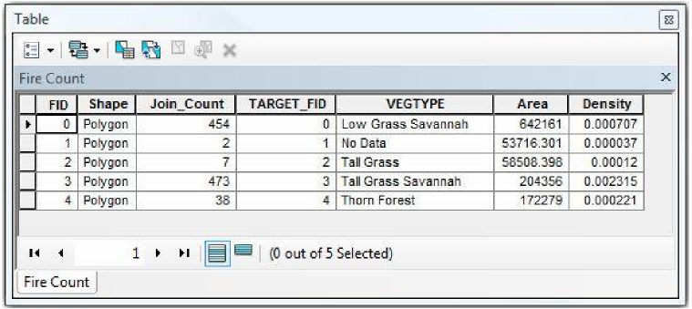

1. Close the attribute table and save your map.

**PART 7: Creating a Graph**

*Another feature of ArcMap is the ability to make simple graphs of data in the attribute table and add it to your final layout. In this exercise, we will make a pie chart of the density data we have just calculated. (It should be mentioned that all the attribute data can be exported and opened in other formats, such as Excel- but we can make charts here in ArcMap.)*

1. In the options menu (top left button) of the **Fire Count** attribute table, scroll down and select ‘Create Graph’ to open the Graph Wizard.

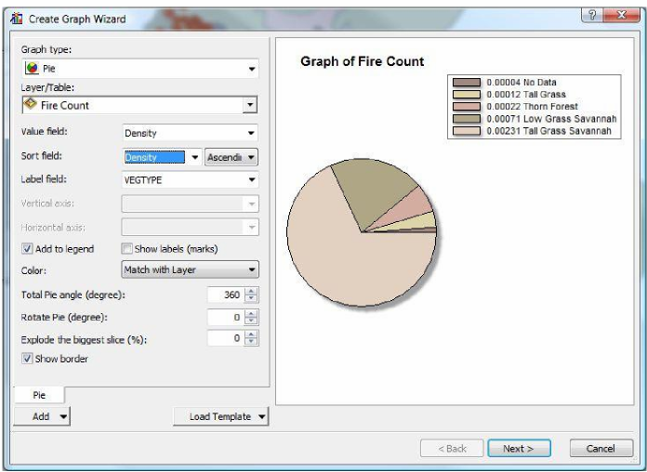

1. In the graph type drop-down menu, select ‘Pie.’
2. Leave **Fire Count** as the target layer, and select ‘Density’ in the value field.
3. Notice that the graph’s legend automatically displays the density values, but does not label which value belongs to which density type. Also notice that the pie chart is symbolized with the same colors as your map. If you want to adjust the colors, go back into layer symbology and adjust accordingly.
4. To add density type information, select the ‘VegType’ field in the label box. You may also sort the density field if you wish. Then click Next.

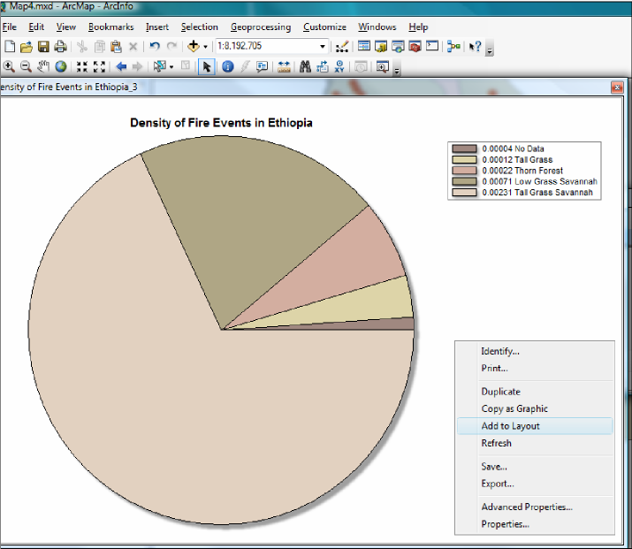

1. On the second wizard screen, change the title to something more meaningful- such as Density of Fire Events in Ethiopia.
2. Click Finish to create the graph.
3. If you are satisfied with the way the graph looks, right click anywhere within the graph screen and select ‘Add to Layout.’ (If you would like to make any changes, double click to reopen the graph wizard.)
4. To see your graph and adjust its size, switch from data view to layout view.

**PART 7: Preparing to Print**

1. Now that we have finished calculating (and graphing) all of the information we were looking for, the final step is to create a map for publication.
2. Your map should plot the location of fire events within the different land cover types of Ethiopia, and the final layout should also include the graph you just created.
3. Make sure to include all pertinent cartographic details- legend, scale bar, etc.

**PART 8: Extra Challenge**

Create a thematic map showing the density of fire events within landcover types in Ethiopia.

You can symbolize the data either by:

1. Using the previously calculated density field, or
2. Normalizing the count field by the area field in layer symbology